

MINOR PROJECT SYNOPSIS ON

Emotion Detection from Speech using Machine Learning

submitted in partial fulfilment of the requirements for the award of degree of

AMITY SCHOOL OF ENGINERING AND TECHNOLOGY

Submitted by: Supervised By:
Sukhman Arora Dr. Lokesh Pawar
A25305223154 Associate Professor
Amity University, Mohali

AMITY UNIVERSITY PUNJAB, MOHALI, INDIA

CONTENTS

Title Page No.

Abstract i
- Introduction 1
- Methodology 1
- Tools and Technologies 3
- Project Plan 4

Abstract
Human speech carries more information than just words. It also reflects the emotional state, intention, and communication style of the speaker. Detecting these emotions automatically from speech signals is an important task in artificial intelligence and speech processing.
This project focuses on developing a system that can analyze speech recordings and identify the emotional tone of the speaker. The system uses the RAVDESS emotional speech dataset, which contains audio recordings expressing different emotions. The speech signals are processed and converted into numerical features using Mel-Frequency Cepstral Coefficients (MFCC). These features represent the important frequency characteristics of speech.
Machine learning algorithms are then used to classify emotions such as happy, sad, neutral, and excited. In addition to emotion detection, the system will also identify the speaker name from a limited set of speakers and classify the speech type, such as teaching or knowledge sharing.
The final system will generate a natural language output sentence describing the speaker and their emotional state. This approach demonstrates how artificial intelligence can analyze human speech patterns and improve communication between humans and machines.

- Introduction
Speech is one of the most natural forms of communication between humans. Apart from conveying information, speech also expresses emotions, intentions, and attitudes. Detecting these emotional signals from speech is an important research area in artificial intelligence and speech processing.
Speech Emotion Detection systems analyze voice signals to identify emotional states such as happiness, sadness, anger, or neutrality. These systems are used in many applications including virtual assistants, customer service analysis, education technology, and mental health monitoring.
This project aims to develop a speech analysis system capable of detecting emotions from speech audio signals. The system will use the RAVDESS dataset, which contains emotional speech recordings in .wav format. The dataset includes multiple actors expressing different emotions in controlled speech recordings.
In addition to detecting emotions, the proposed system will also identify the speaker identity and classify the speech type, such as teaching or knowledge sharing. This will allow the system to provide a more detailed understanding of the speech context.
The final output of the system will be generated in the form of a sentence describing the speaker and the emotional tone of the speech. This project demonstrates how machine learning techniques can be used to analyse speech patterns and automatically interpret human emotions.
- Methodology
The proposed system follows several stages to develop an automated speech emotion detection system.
  - Dataset Collection and Analysis
The project uses the RAVDESS dataset, which contains emotional speech recordings in .wav format. The dataset includes both speech and song recordings from multiple speakers expressing different emotions.
The modality code present in the dataset filenames is used to identify whether the recording contains speech or song. Only relevant speech recordings are selected for emotion detection analysis.
  - Audio Preprocessing
Before feature extraction, the audio recordings must be processed to improve quality and consistency.
The preprocessing stage includes:
- Loading audio signals from .wav files
- Normalizing audio signals
- Preparing the audio data for feature extraction
These steps ensure that the system focuses on meaningful speech characteristics rather than noise or recording variations.
  - Feature Extraction using MFCC
The system extracts Mel-Frequency Cepstral Coefficients (MFCC) from the speech audio signals. MFCC is a widely used technique in speech recognition that represents the frequency characteristics of speech in numerical form.
These features capture important patterns in the speech signal that can be used by machine learning models to recognize emotions and speaker identity.
  - Model Training and Prediction
Machine learning algorithms are trained using the extracted MFCC features and labeled emotion data. The trained model learns patterns that distinguish different emotional states.
The model is then tested using new speech inputs, including custom speech recordings from friends, teachers, and the project developer.
The system predicts:
- Speaker name
- Emotion expressed in speech
- Type of speech (teaching, knowledge sharing, or conversation)
The final output is presented as a descriptive sentence.
  - System Architecture

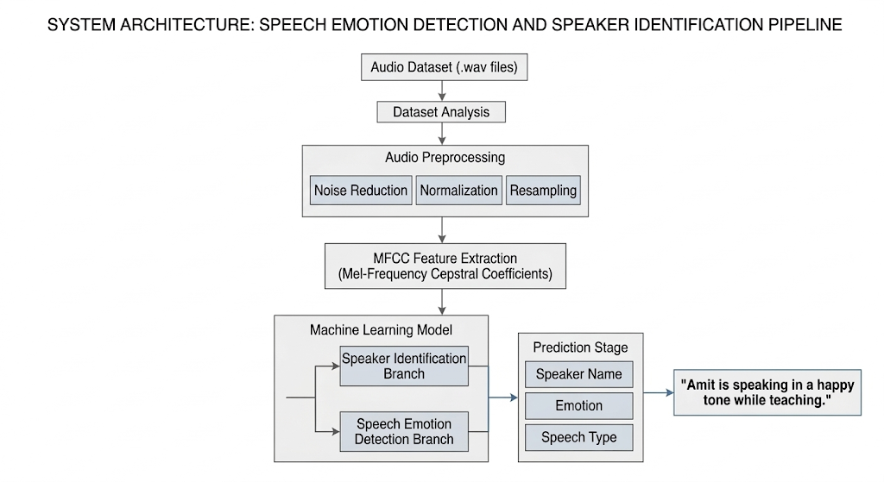
- Tools and Technologies
  - Programming Language:
Python
  - Libraries:
- Librosa : Audio processing and feature extraction
- NumPy : Numerical computation
- Matplotlib : Visualization of audio features
- Scikit-learn : Machine learning model development
  - Development Environment:
Jupyter Notebook / Visual Studio Code
  - Dataset:
RAVDESS Emotional Speech Dataset

- Project Plan
  - Literature Review and Dataset Study
The first phase involves studying existing research in speech emotion recognition and understanding the structure of the RAVDESS dataset. The dataset is analyzed to identify relevant speech recordings and understand the encoding of emotions and modalities.

4.2 Audio Dataset Analysis
Speech recordings are analyzed and filtered to select appropriate .wav files. The modality codes in the filenames are used to distinguish between speech and song recordings. This step ensures that only speech recordings relevant to emotion detection are used in the model.

  - Feature Extraction
MFCC features are extracted from each audio file. These features convert the speech signal into numerical representations suitable for machine learning algorithms.
Feature extraction is a critical step that allows the model to learn meaningful patterns from speech signals.

  - Model Training and Testing
Machine learning models are trained using extracted features and labeled emotions. The model is evaluated using test data and custom speech recordings to measure performance and accuracy.
  - Result Generation and Output
The final system analyzes new speech input and generates an output sentence describing the speaker, emotion, and speech type. This demonstrates the practical use of artificial intelligence in understanding human speech and emotions.

